Cymbal Braille

Created by: Samantha Zauner

Purpose: This file folder game can be used with low vision students who are beginning to learn braille.

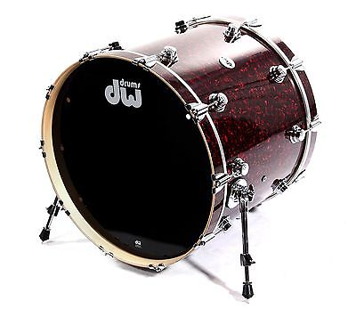
Dots 1, 2, 3, 4 and 6

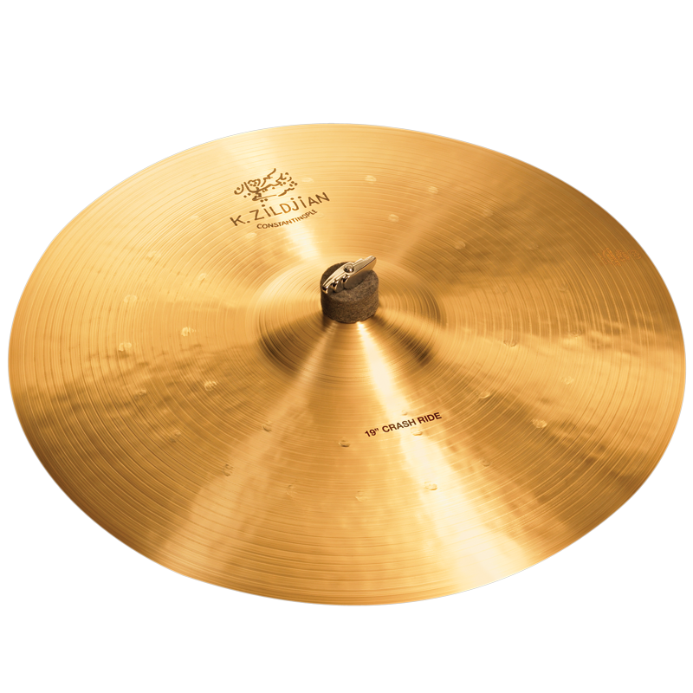

Dots 2, 3, 4 and 6

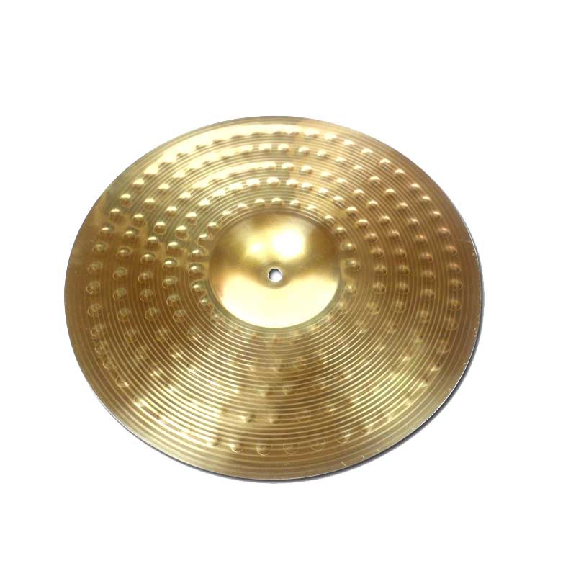
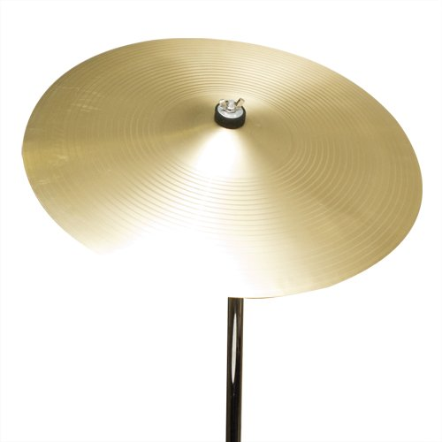

Dots 1, 2, 3, 5 and 6
Dots 2, 3, 4, 5 and 6

Dots 1, 2, 3 and 5
Dots 1 and 6

]

Dots 2, 3 and 5

Dots 3 and 4
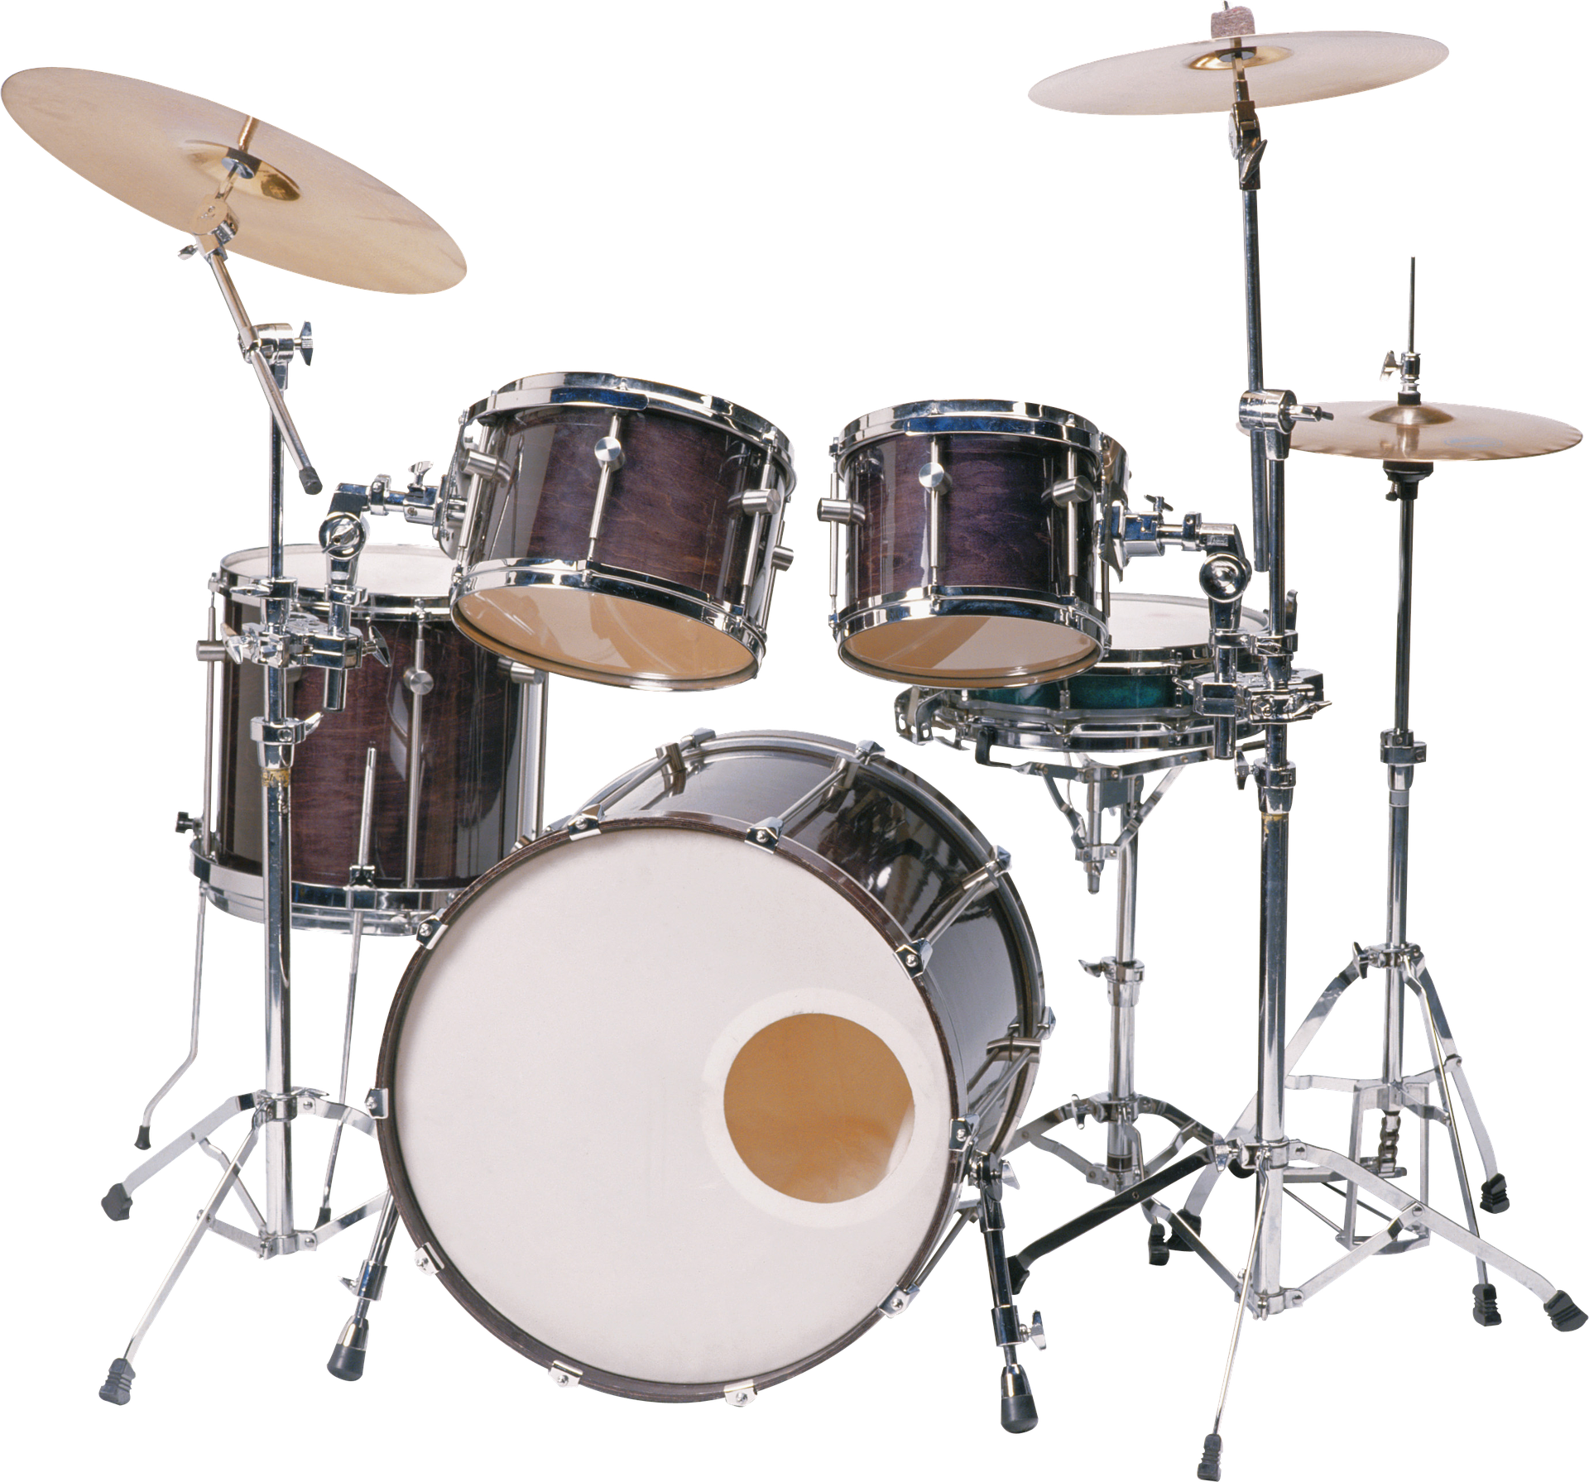

to
and
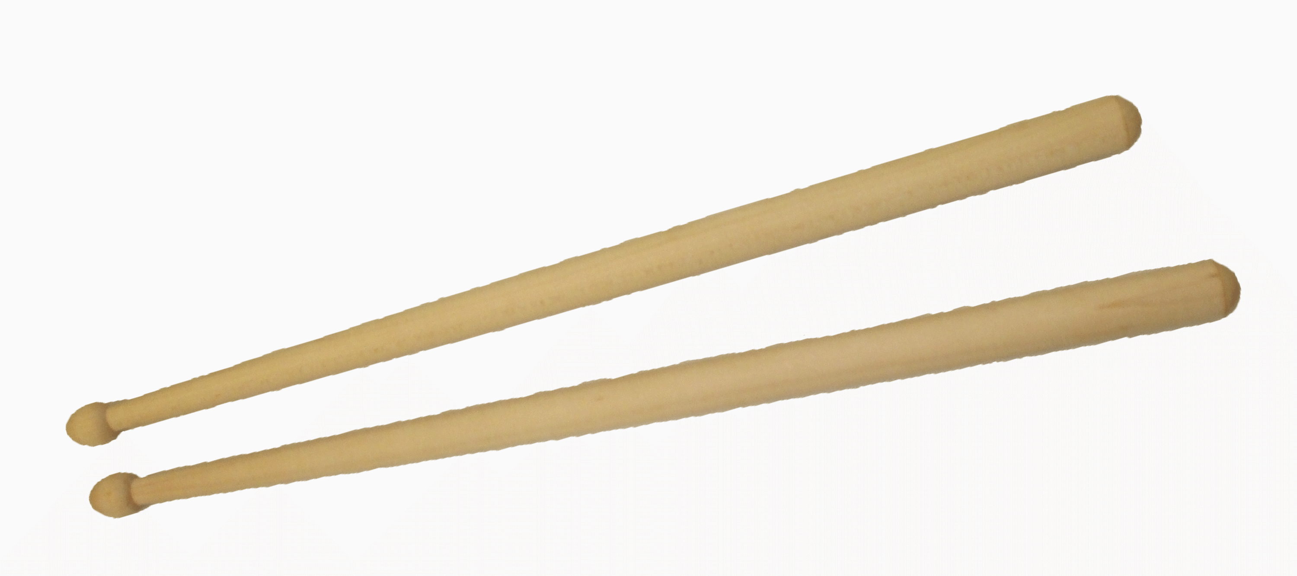

the
child

still
with

of

Answer Sheet

Visual | Dot Formation | Word
! | Dots 2, 3, 4 and 6 | the
& | Dots 1, 2, 3, 4 and 6 | and
( | Dots 1, 2, 3, 5 and 6 | of
) | Dots 2, 3, 4, 5 and 6 | with
* | Dots 1 and 6 | child
/ | Dots 3 and 4 | still
6 | Dots 2, 3 and 5 | to

