Traffic Braille

Letters- W, P, O, K, E, S, R and M

Created By: Samantha Zauner

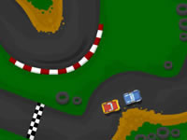



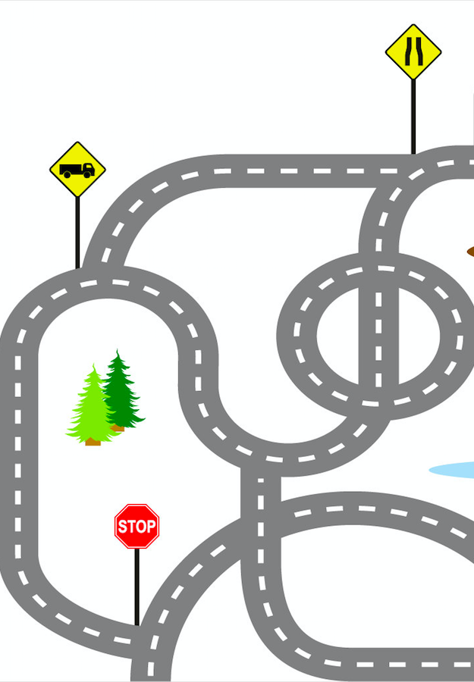

**Dot 1, 3 and 4**

**Dot 1 and 5**





**Dot 1, 3 and 5**





**Dot 1 and 3**





**Dot 2, 4, 5 and 6**



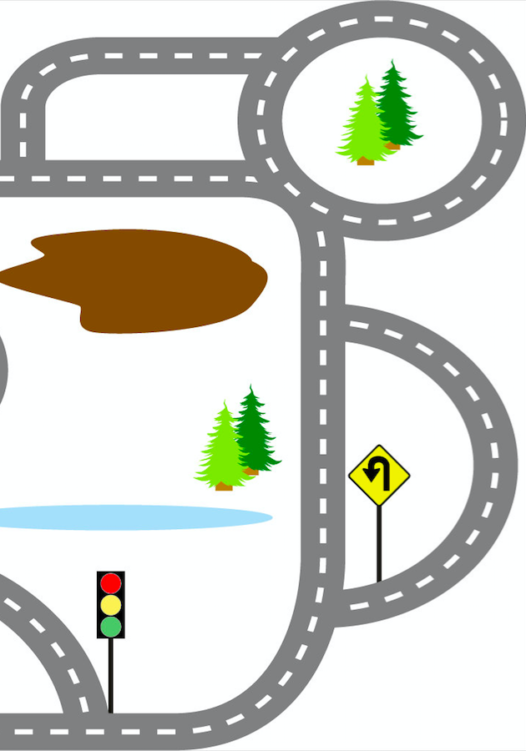

**Dot 2, 3 and 4**

**Dot 1, 2, 3 and 5**



Macintosh HD:Users:zauners:Desktop:Screen Shot 2016-02-18 at 3.26.19 PM.png

**Dot 1, 2, 3 and 4**





Macintosh HD:Users:zauners:Desktop:Screen Shot 2016-02-18 at 3.26.19 PM.png









**E**

**W**

**K**

**M**

**O**





**R**

**P**

**S**